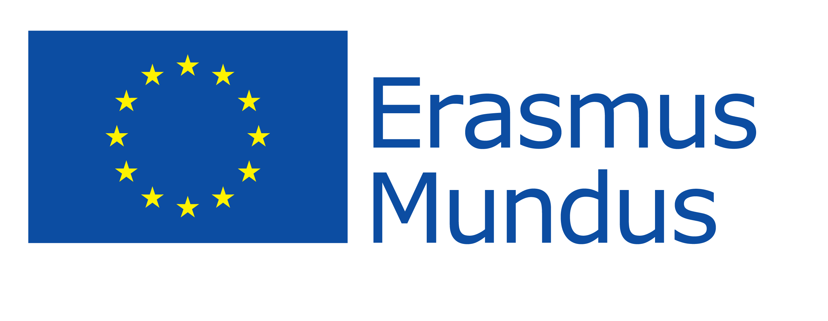

Application Form 2013 / 2014
For EU Applicants

This application form should be completed in block letters (in ENGLISH or GERMAN) in order to be easily copied and/or faxed.

1. General Information

1.1. Please mark
Target Group 1 (Partner university)

Undergraduates (6 months) Masters (6 months)
Doctorates (6 months) Academic Staff (1 month)

OR
Target Group 2 (Applicant from an Institution, which is not a Member of the Partnership)
Masters (6 months) Doctorates (6 months)
1.2. Current occupation
1.3. Home Institution, City

1.4. If you are a student: | Attach the photo,  please –  do not staple!
- Field of study
- Faculty
- Academic year
- Subject Code (will be filled in by local coordinator)

2. Applicant´s personal data

- Family name (as indicated in the passport)
- First name
- Address (Street + number, Zip code, City)
- Number of international passport
- Expiry date
- Mobile number
- E-Mail
- Date of birth
- Place of birth, country
- Sex
- Nationality
- Family status

3. Coordinator at the home university (name, phone, email) (for TG1 only):

4. Receiving Institution

Institution, Country | Preferred start of the semester (winter or summer) | Field of studies (max. 2 study programmes, please provide the exact name of the programme) | Duration of stay in months
1st priority

2nd priority

5. Secondary School Education

5.1. Name of the School |  | From…to…

5.2. Final school certificate
- Exact date (dd.mm.yyyy)
- Original name of the document
- Country

6. Higher Education (incl. study abroad)

Programme of study | Institution | Period

7. Foreign Language Competence

7.1. Which language certificates do you have?

7.2. Other languages | In this language I can participate actively in scientific discussions without difficulties. | I have sufficient knowledge to follow lectures. | I would have sufficient knowledge to follow lectures, if I had some extra preparation.

8. Recommendation letter

Please add the recommendation letter in a separate document!

Reference by:
- Title, Name
- Position/ Occupation
- Contact (phone, email)

9. Have you ever been awarded with an Erasmus Mundus Grant?

If yes, when and at which university?

10. Only for PhD and Academic Staff

10.1.
Please specify your doctoral degree and the specific research you want to do at a Russian University. Please add on a separate document your research proposal.

- PhD degree
- Research
- Currently affiliated with (Institution)

10.2. Degrees held
Date | Exact degree title | Subject | Result

I certify that the information in this application is accurate. I do not have any mental diseases and disabilities, which would compromise my participation in the Erasmus Mundus Action II „International Academic Mobility Network with Russia“ (IAMONET-RU). I certify that I will immediately inform the coordinator of the Erasmus Mundus Action II „IAMONET-RU” Project about personal changes and additions. I agree that this application and accompanying documents can be forwarded to partner institutions cooperating in this programme.

Place, date |  | Signature of the applicant

